EXPORT DUMP VERSI MIGRATION ORACLE 19
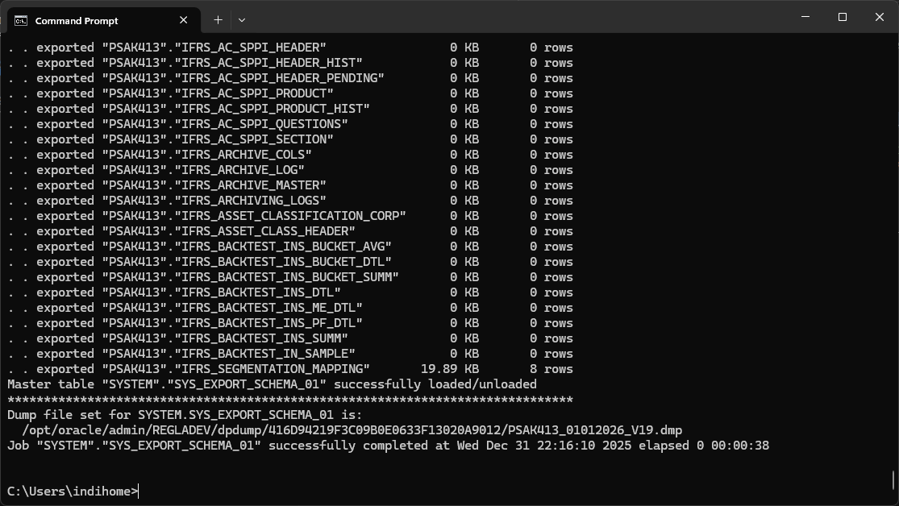
EXPORT DUMP VERSI NORMAL
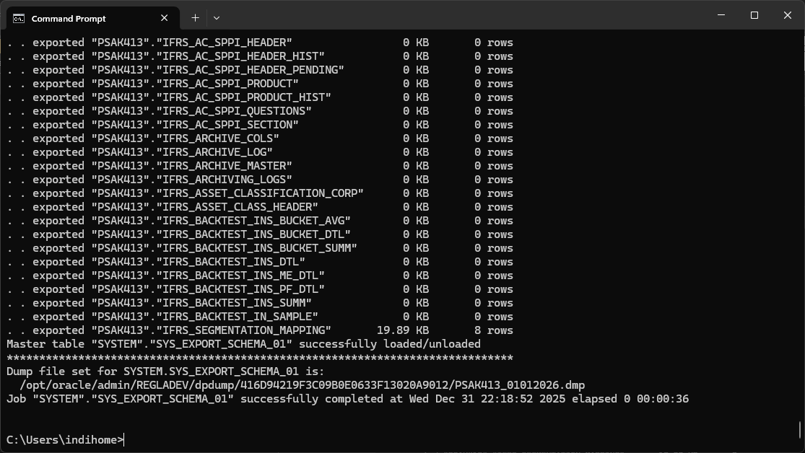

CEK FOLDER BACKUP DI ORACLE
SELECT directory_name, directory_path FROM dba_directoriesWHERE directory_name = 'DATA_PUMP_DIR';
CREATE FOLDER BACKUP
CREATE DIRECTORY EXP_SCHEMA AS '/opt/oracle/admin/backup/exp_schema';

